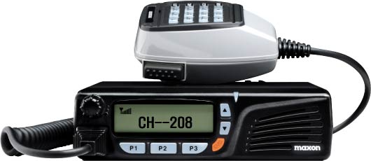

PM200/250
Programming Manual

Contents
Introduction 6
Programmer Installation 7
Programming 7
Help files and Language settings 8
Tool Bar 9
Icon 9
Programming Mode 10
Reading 10
Writing 10
Cloning 10
Standard non-selcall parameters 11
Radio Parameters 11
LCD Logo 11
Speaker 11
Power on Channel 12
Select radio parameters 13
Frequency 13
CTCSS 14
DCS 15
Channel Spacing 15
Contents

Group Setting 15
Clear One Channel 16
Clear All Channels 16
TX Power 16
Options 17
Programmable Function Keys 17
Power 17
Light 18
Monitor 18
Lock 18
Scan 18
Public Address 18
Open/Close 18
Selcall 18
SMS 18
1200/2400 18
DTMF 18
Group 18
Asic 18
Settings and Timings 19
PTT Timer 20
TX Timer 20
TX Inhibit 20
TX Inhibit Alert 20
Open Lock 21
Busy Lockout 21
Mark Idle 21
TX Delay 21
Monitor 21
Hook 21
Hook Scan 22
Beep 22
Public Address 22
Power Up Alert 22
Power up 22
Auto Mute 22
Contents

Auto Mute Timer 22
Scanning Parameters 23
Scanning examples 23
Priority Look Back Scan 24
Scan channel delete 25
Group Scan edit mode 25
Priority scan channel edit 25

Selcall tones and sequences 27
Tone sets 27
Sequence 28
Tone Length 28
Lead In 28
1st Tone 28
Lead Out 28
Encode 29
Emergency Sequence 29
Check Open 29
Check Busy 29
Encode Alert 30
Repeats 30
Cycle Repeat Time 30
Transmit Timer 30
ANI 30
ANI Sequence 30
ANI at 30
Multi ANI Delay 30
Call1 /Call2/Call3 Sequence 30
Check Open 31
Check Busy 31
Encode Alert 31
Ack.1 to Ack.4 31
Decoder 32
Call1 /Call2/Call3 32
Control 1 to 4 32
Action 33
Contents
Close 33
Open 33
Stun 33
Revive 33
Covert On 33
Covert Off 33
Acknowledge 34
Selcall Text 34
Group Call 34
Decoder Tone Length 34
Covert Timer 34
TX Timer 34
RX Timer 34

DTMF and Selcall Status 35
Selcall Status 35
DTMF 36
DTMF lead in time 36
DTMF lead Out Time 36
DTMF Mark Time 36
DTMF Address 36

MODEM - SMS 37
SMS 37
TX On Delay 37
TX Off Delay 37
Contact Details 38

Note:
Although this manual is a generic manual for PM200 and PM250 there are a number of differences between PM200 and PM250. A separate appendix has been written which includes the drawings and part list for the PM250. Please be aware that all drawings and parts are only relevant to the PM200. All features and functions are relevant to both models. The PM250 appendix can be downloaded from the MaxonCIC website http://www.maxoncic.co.uk/
Introduction

Contents

Introduction
The PM200 Programming Manual is to be used in conjunction with the PM200 programming software and programming lead (PK –PM200-250-01). Combined these items will program the PM200 personality. The Selcall, DTMF, SMS and data features, support a wide range of signaling and control functions including:
Introduction
- Fully programmable tone sets- including EEA, CCIR and ZVEI
- Automatic Number Identification (ANI) on PTT
- Emergency Calling
- Stun and Revive
- Group Calling
- Covert listening
- SMS (Short message Service)
- Data Facilities Socket
- Programmer definable Keys
- Optional Penalty Modes and PTT Time Out
- DTMF Status Transmission

The PM200 is programmable via the 15 way D-type socket at the rear of the radio using the PM200 Programming Kit. This is made up of PM200 programming software, and the programming lead PK-PM200-250-01.
The software is best downloaded from the Maxon CIC EUROPE Web-site (http://www.maxoncic.co.uk). The software is an XP Windows based package.

Operating System
Microsoft Windows 98, 2000, NT, XP

Programmer Installation
Programmer Installation & Programming
Your PM200 programmer is best downloaded from the Maxon web-site, but if you have difficulty downloading the software then you can obtain a copy of the software through Sales. The software comes on a CD-ROM disk. Insert the disk into your CD drive. Click on ‘Start’; click on ‘Run’. Type,‘d:\setup’ or click on ‘Browse’ and then look for the setup file on your CD drive. Double click on the Set-up icon to install. Follow on-screen instructions.
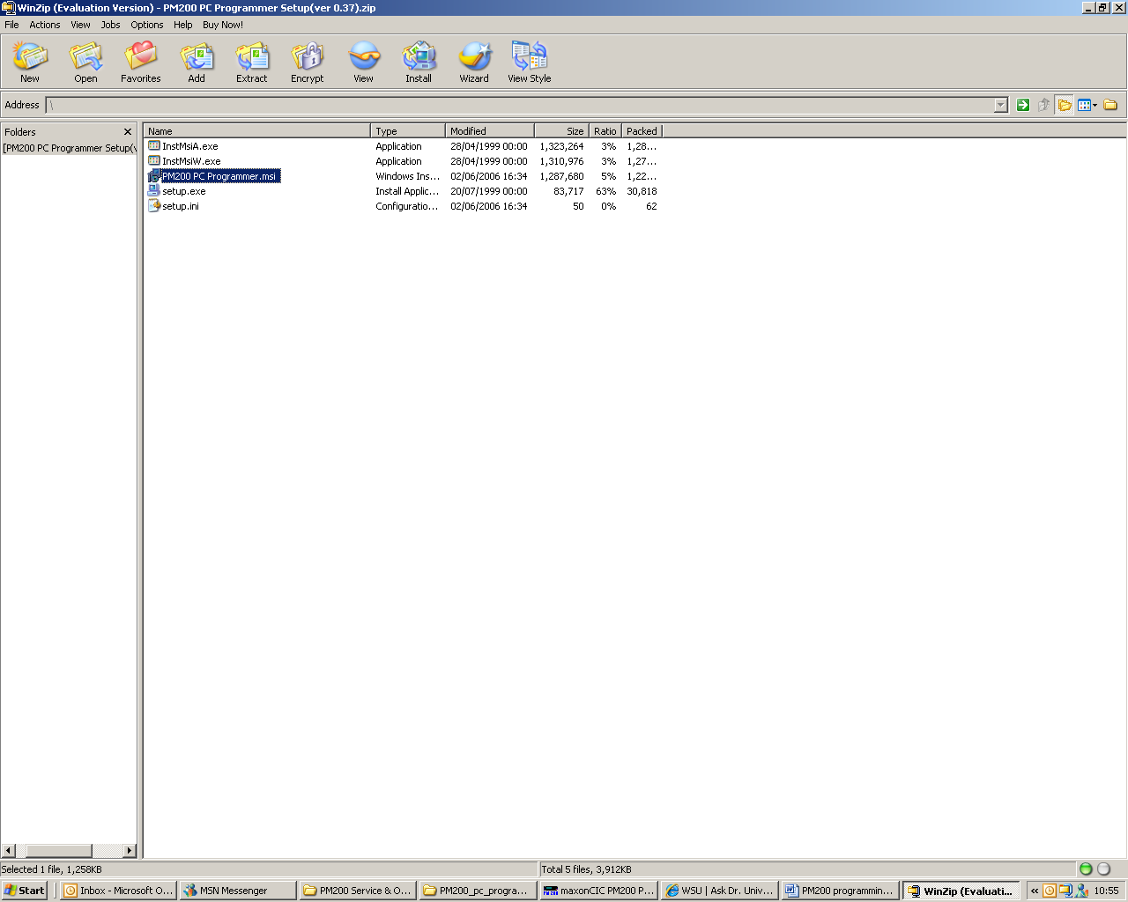

Programming
This programmer will program the radio parameters and the Selcall features without the need for cable change or software change. All necessary features can be accessed from the front window via Tabs.
To open the programmer, double-click on the PM200 icon in the Start Menu Taskbar.
The PM200 Programming utilizes COM 1 on the PC as the default Programming Port. This can be changed under the “Program (P)” “Port (P)”, along the Tool bar. See below: -
Setup of Com Ports
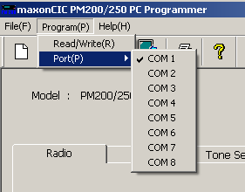 (Fig 1)

Files can be saved, and viewed at a later date, or previously saved files opened, using the “File (F)” Menu along the Tool bar.
Please note that it may prove helpful to create named folders in the PM200 directory, to save files specific to that radio and it’s’ band, i.e. PM200_WITH_SELCALL, etc.
Help files
If the help files fail to initiate please follow the instructions below. (This instruction is for XP only)
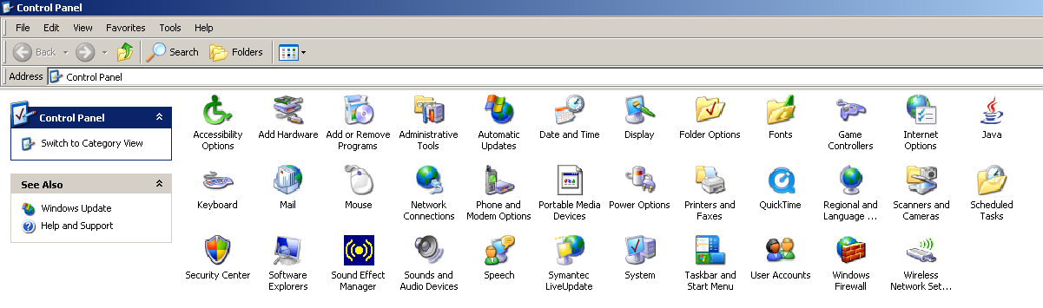

(Fig. 2)

Click on Control panel and double click the Regional and Language
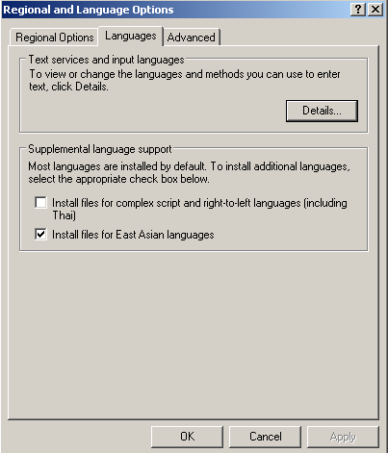
Click on Languages and make sure install East Asian languages are ticked.
Then Click Details.
Help Files & Language Settings

(Fig. 3)

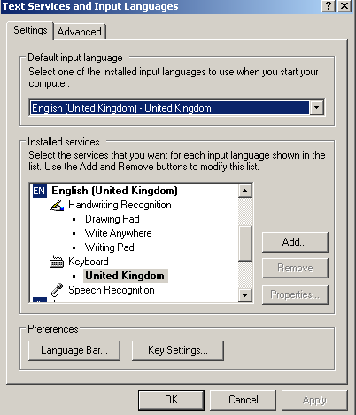
Click Advanced.

(Fig. 4)
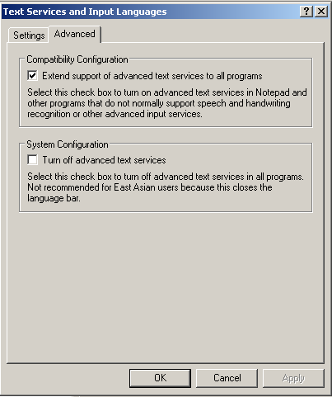
Make sure the Compatibility Configuration is ticked.

Click on apply and Click OK you may have to restart your PC.

This has now completed the set-up for reading the help files. Please check you can now read the help files.

(Fig.5)

Tool Bar
There are 3 items in the top right hand side tool bar, File(F), Program(P) and Help(H). There are seven printing options, Exit, New programming page, Open pre-saved files, Save items and Open ATE file (please note this for engineering use only).
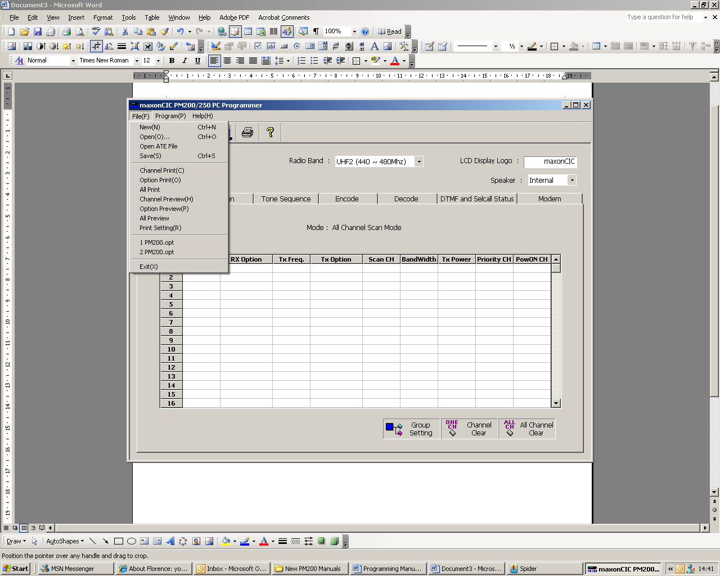 (Fig. 6)
Help Files & Language Settings

Icon Bar
There are seven icons along the top right hand side (see below).
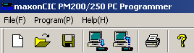 (Fig.7)
Write
Read
Print
Open File
Help
New File
Save

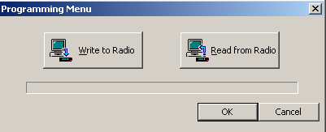
To Program or to Read from the radio click the “Program (P)” menu along the Tool bar. Click on “Read/write(R)”. Alternatively use the read/write icons programming menu: -

Programming Mode
To place the PM200 into program mode, connect PK-PM200-250-01 programming lead to the PC and the PM200 (via a 15way High density D-type connector please see rear panel layout Fig1). Switch the PM200 on with the programming lead connected. If the PC-program enable port is active status, the PCU enters programming mode. The PM200 should now display “ProGrAm”

Reading
PM200 assumes the PC is ready to receive data. When serial Commands are sent through the lead, PM-200 will transmit the data. During this sequence, the Red LED will flash. In PC program Reading Mode, the LCD displays “Prog-r”.

Writing
PM200 assumes the PC is ready to transmit data. When serial Commands are sent through the lead the PC then starts the transmission of data. During this sequence, the Green LED flashes. In the PC program Writing Mode, the LCD displays “Prog-w”.
Programming

Cloning
Cloning is a method of programming another radio with the same profile without using a personal computer or laptop. The master radio is the radio with the desired frequencies the slave radio is the radio to be programmed.
- Press and hold ▲ button on power up on the radio which you would like to copy. In this mode, radio will display “MASTER”. The radio is now ready to transmit programming file.
- Press and hold the▼ button on power up on the radio you would like to program. In this mode, radio will display “SLAVE” with green led blinking.
- Connect the cloning cable.
- Press the master radio ▼ button.
- After cloning, the slave radio will display “ TURN OFF” message, and the master radio displays ” MASTER” message on LCD. Turn off both radios.

Standard Non-Selcall Parameters

Radio parameters
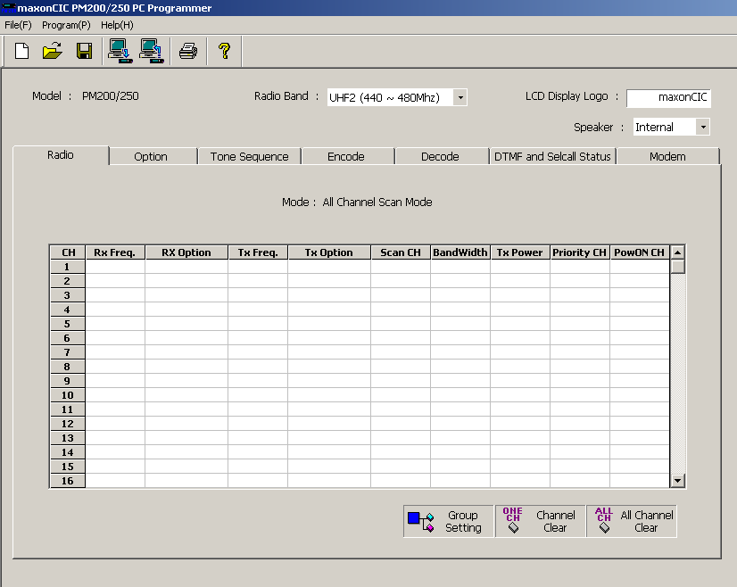
Standard Non-selcall Parameters

(Fig.8)

Radio Band
To select Band click on “Radio band”
UHF2 (440~480MHz)
VHF2 (148~174MHz)

LCD Display Logo
To change power up Logo, type new message in the LDC display logo box. Maximum of 9 characters.

Speaker Internal/External
This feature switches the internal/external speaker on and off. Disabled the internal speaker is on, Enabled internal speaker is off. Please note the internal-external speaker can be switched by the user. Press and hold the P1-P3 button on switch on. This will toggle the internal/external speaker.

Power on channel
Double click power on channel (please note this can only be done if the frequencies are already entered). When activated the radio will power up on selected channel, if not selected, the radio will power up on the last channel used. This parameter is marked “PowON CH”.

Standard Non-selcall Parameters

Select Radio Parameters

Frequency
To select the correct frequency double click on the desired channel as per figure 8.
Frequency menu
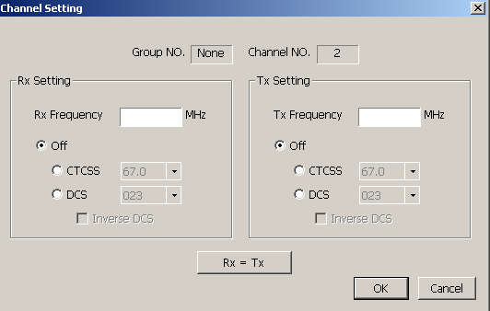
Select Radio Parameters

(Fig.9)
Channel and Group numbers are displayed at the top of dialogue box.
Enter TX/RX frequencies using decimal point. If the frequencies are back to back the “RX=TX” will copy the frequency to both settings.
Note: Frequency must be divisible by 6.25 kHz.

CTCSS
To set the CTCSS (Continuous Tone Coded Squelch System) click on correct RX/TX CTCSS, scroll to correct tone frequency and select by single click. See table for available tones.
CTCSS & CTCSS Table
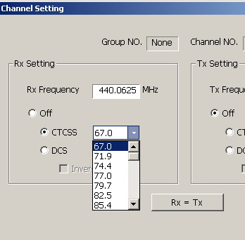

(Fig.10)

No. | Freq. Hz | No. | Freq. Hz | No. | Freq. Hz | No. | Freq. Hz
01 | 67.0 | 11 | 97.4 | 21 | 136.5 | 31 | 192.8
02 | 71.9 | 12 | 100.0 | 22 | 141.3 | 32 | 203.5
03 | 74.4 | 13 | 103.5 | 23 | 146.2 | 33 | 210.7
04 | 77.0 | 14 | 107.2 | 24 | 151.4 | 34 | 218.1
05 | 79.7 | 15 | 110.9 | 25 | 156.7 | 35 | 225.7
06 | 82.5 | 16 | 114.8 | 26 | 162.2 | 36 | 233.6
07 | 85.4 | 17 | 118.8 | 27 | 167.9 | 37 | 241.8
08 | 88.5 | 18 | 123.0 | 28 | 173.8 | 38 | 250.3
09 | 91.5 | 19 | 127.3 | 29 | 179.9
10 | 94.8 | 20 | 131.8 | 30 | 186.2

(Fig.11)
CTCSS

DCS & DCS Table
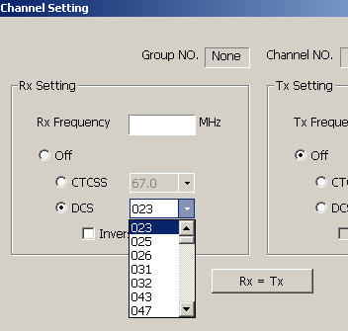 (Fig.12)
To set the DCS (Digital Coded Squelch) click on correct RX/TX DCS, scroll to correct code tone and select by single click. See table for available codes. For inverse code tick Inverse DCS.
Octal Code | Octal Code | Octal Code | Octal Code | Octal Code | Octal Code | Octal Code | Octal Code | Octal Code
023 | 071 | 134 | 223 | 306 | 411 | 503 | 631 | 734
025 | 072 | 143 | 226 | 311 | 412 | 506 | 632 | 743
026 | 073 | 152 | 243 | 315 | 413 | 516 | 654 | 754
031 | 074 | 155 | 244 | 331 | 423 | 532 | 662
032 | 114 | 156 | 245 | 343 | 431 | 546 | 664
043 | 115 | 162 | 251 | 346 | 432 | 565 | 703
047 | 116 | 165 | 261 | 351 | 445 | 606 | 712
051 | 125 | 172 | 263 | 364 | 464 | 612 | 723
054 | 131 | 174 | 265 | 365 | 465 | 624 | 731
065 | 132 | 205 | 271 | 371 | 466 | 627 | 732

(Fig. 13)

Channel Spacing
DCS
Select the correct channel spacing by double clicking the Bandwidth parameter.
S = 25 kHz channel spacing.
N = 12.5 kHz channel spacing.

Group Setting
To select a group single click on Group setting.
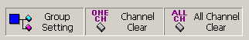
Group (Fig.14)
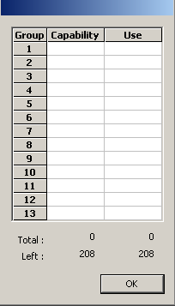

Group channel numbers (Fig.15)
Double click the correct group number.
Enter the number of channels required in the capability box and press OK.
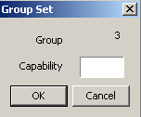 Group number (Fig.16)
Once frequencies have been added the number of channel will show in the Use boxes.

Clear One Channel
To clear one channel, highlight channel single click clear channel

Clear All Channels
To clear all channels

TX Power
Group Setting
There are two settings for TX power high and low
Low = 2 Watts
High = 25 Watts

Options

Programmable Function Keys
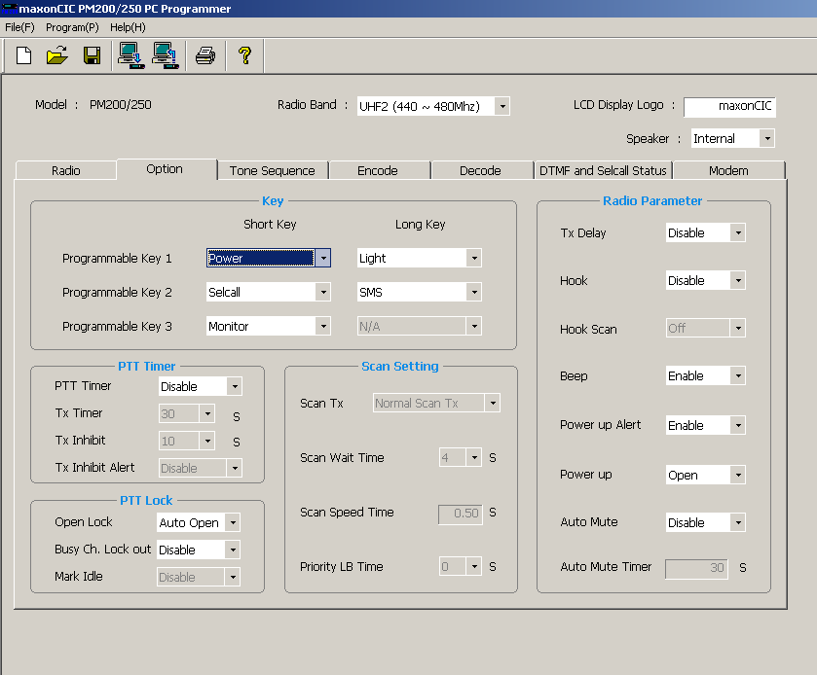
(Fig.17)
The following functions can be assigned to [P1] [P2] [P3] programmable function keys. These are located on the bottom left of the radio. Each button has two actions (a short and long press) giving a total of six button assignments. Select correct feature using scrolling bar on programmable key 1 – 3.
Options
There are 13 programmable features that can be assigned to the [P1] [P2] [P3] buttons. (See overleaf).
NOTE: When selecting the monitor button and all of the remaining five buttons are still required, use monitor with long press as setting monitor as short press will blank out the long press option.

Power To toggle the transmit Output power between High and Low
Light Press to toggle the Auto mode, Light Off or Light On mode.
Monitor Defeats the squelch operation and un-mutes the speaker on the selected channel.
Lock This function can disable all keys except PTT and Emergency Key.
Scan Starts and cancels scanning operation.
Public Address When external speaker is attached the radio will output voice audio.
Open/Close Toggles the radio status between Open or Close mode.
Selcall Key to enter the Selcall selection mode.
SMS Key to enter the SMS selection mode.
1200/2400 Toggles the SMS baud rate1200 bps or 2400 bps
DTMF To enter DTMF selection mode.
Group Key to enter the group selection mode.
Asic The Asic key is only available on programmable Key 3 long Key. The Asic mode changes the radios default Set-up so should only be done by an authorized dealer. For more details please see operation manual.

Options

Settings and Timings
Settings and Timings
The following features may be selected with full explanation on the next page:
Parameter Group | Parameter | Selection | Note
PTT Timer | PTT Timer | Enable/Disable | Switches timer functions On/Off
PTT Timer | TX Timer | 10 – 990 sec | Limits TX Time
PTT Timer | TX Inhibit | 5 - 75 sec | Inhibits TX for specified time after TX timer
PTT Timer | TX Inhibit alert | Enable/Disable | TX inhibit alert
PTT Lock | TX Delay | Off or On | Eliminates Squelch tailing noise
PTT Lock | Open Lock | Off / Auto Open / LockPTT | Off allows PTT to operate regardless of whether the radio is in an open state (monitor open) or not,  Auto Open ‘Auto Open’ opens the monitor of the radio after pressing PTT.  Lock PTT ‘Lock PTT’ prevents the keying of PTT unless the radio is open
PTT Lock | Busy Lockout | Enable/Disable | Prevents TX when channel is busy.
PTT Lock | Mark Idle | Enable/Disable | Busy Channel Lockout is on and carrier is detected, the radio shall be permitted to transmit with valid SAT
Scan Setting | Scan TX (without Priority programmed). | Normal Scan TX / RX only no TX | See scanning Parameters
Scan Setting | Scan TX (with priority programmed). | Priority scan TX / Priority only TX | See scanning Parameters
Scan Setting | Scan Wait | 0 – 15 sec | Delay before scanning starts
Scan Setting | Scan Speed Time | 0.5 – 2 sec | Time for one complete scan
Scan Setting | Priority LB Time | 0 – 7 sec | Time for look back  Settings and Timings
Radio Parameter | TX Delay | Enable/Disable | Eliminates squelch tail at end of Transmission
Radio Parameter | Monitor | Enable/Disable | The monitor button overrides the squelch circuit
Radio Parameter | Hook | Enable/Disable | Changes the action of CTCSS depending on grounding status of the microphone
Radio Parameter | Hook Scan | On or Off | Changes the action of scanning depending on grounding status of the microphone
Radio Parameter | Beep | Enable/Disable | Gives audible alert tones
Radio Parameter | Public Address | Enable/Disable | Passes audio to external Accessory Socket
Radio Parameter | Power up Alert | Enable/Disable | Gives audible alert tones
Radio Parameter | Power up | Open / Close | Open or closed on switch on- Selcall
Radio Parameter | Auto mute | Enable/Disable | Automatically closes the squelch after given time
Radio Parameter | Auto mute | 0 – 250 sec | RX Off Time

(Fig.18)

PTT Timer
The PTT timer is the time limit on transmission.
Enable/Disable

TX Timer
The TX Timeout feature, when enabled, limits the amount of time that a user can continuously transmit.
The time can be set in increments of 10 seconds from 10 to 990 seconds.

TX Inhibit
The TX Inhibit time is the time that the PTT remains inactive after the TX Timeout has occurred. Range is 5 - 75 seconds in 5-second increments.

TX Inhibit Alert
Audible warnings are sounded if the PTT is pressed during the penalty time period.

Open Lock
The radio can control the PTT action in three ways according to the radio busy status.
Settings and Timings
- Off allows PTT to operate regardless of whether the radio is in an open state (monitor open) or not, and does not change the state of the radio.
- Auto Open ‘Auto Open’ opens the monitor of the radio after pressing PTT.
- Lock PTT ‘Lock PTT’ prevents the keying of PTT unless the radio is open.

Busy Lockout
Disables the transmitter and generates an alert if user tries to transmit while the channel is busy. If set to ‘mark idle’ then the radio will transmit when a correct SAT is present.

Mark Idle
- Marked Idle enabled: Can only be enabled if Busy Channel Lockout is ON. If the Busy Channel Lockout is on and carrier is detected, the radio shall be permitted to transmit if the RX squelch option is valid.
- Marked Idle disabled: Eliminates Marked Idle and defaults back to ‘Busy Channel Lockout’.

TX Delay
Eliminates squelch tails for SAT transmissions by removing the SAT tone for approximately 200mS before the end of the transmission.

Monitor
Enables / Disables the monitor button. The monitor button overrides the squelch circuit and any SAT to allow monitoring of the channel.

Hook
With the hook switch enabled and the microphone grounded CTCSS acts normally. With the hook switch enabled and the microphone not grounded CTCSS is defeated.

Hook Scan
Hook must first be enabled, select hook scan on, and scanning will automatically start when microphone is grounded. Select hook scan off and scanning acts normally.
Settings and Timings

Beep
Selects if audio tones are sounded when buttons are pressed, an incorrect operation is performed. If switched off, the LED still continues to flash as necessary.

Public Address
When selected and external speaker is attached, the radio will output voice audio over the external speaker. The radio does not TX a carrier in this mode. P/A will be shown in display when selected. When active allows operator to enable an external speaker and transmit microphone audio only.

Power up Alert
Power up alerts are audible tones informing the user the power has been initiated.

Power up
The radio can be programmed to be either open or closed on power up. This only refers to the selcall state and not squelch.
- Closed: Radio is in muted state.
- Open: Radio is in unmuted state.

Auto Mute
Enabled the radio automatically returns to its quiet state after a period of inactivity (see auto-mute timer below). Disabled the radio remains in its open mode until it is manually put into its quiet state (depending on programming).

Auto Mute Timer
This is the length of time of inactivity after which the radio returns to its quiet state (muted).
0 – 250 sec.

Scanning Parameters

Scanning Examples
Scanning Parameters
Select scan list by clicking the radio tab and double clicking correct channels in the scan CH box
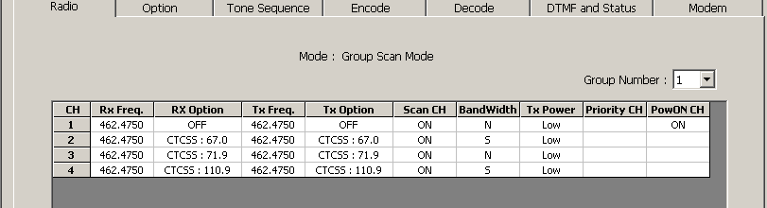
Open the option tab and select the required programmable key, select scan using scroll bar.
With normal scan TX selected, Scan wait time 4 sec. Scan speed 0.50sec.
On pressing scan button, radio will traverse scan list. If correct carrier and CTCSS/DCS are detected, the radio will stop on channel. The user is not permitted to transmit while scanning (INHIBIT will be displayed), only on a stopped channel is PTT allowed. Scan edit can only be used on a stopped channel. Using the ▼ once scanned channel has locked will temporarily delete that channel from the scan list.
With RX only/noTX selected Scan wait time 4 sec. Scan speed 0.50sec.
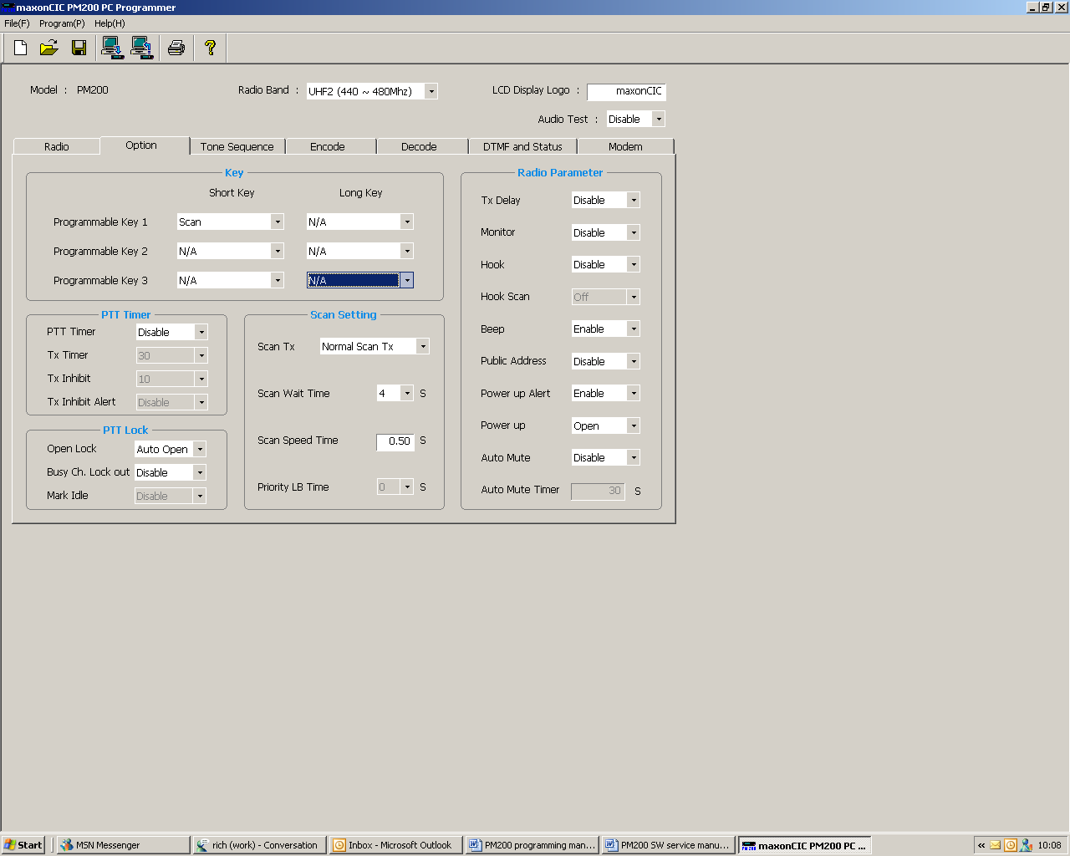
On pressing scan button, radio will traverse scan list. If correct carrier and CTCSS/DCS are detected radio will stop on channel. The user is not permitted to transmit at any time (RX ONLY is displayed), Scan edit can only be used on a stopped channel. Using the ▼ once scanned channel has locked it will temporarily delete that channel from the scan list.

Select scan list by clicking the radio tab and double clicking correct channels in the scan CH box. Select the correct priority channel and double click
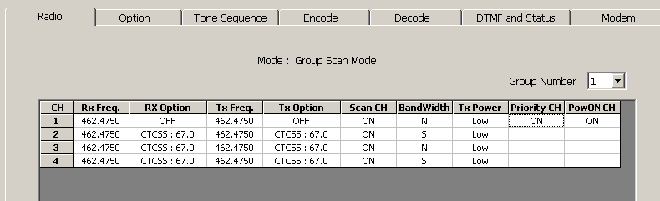
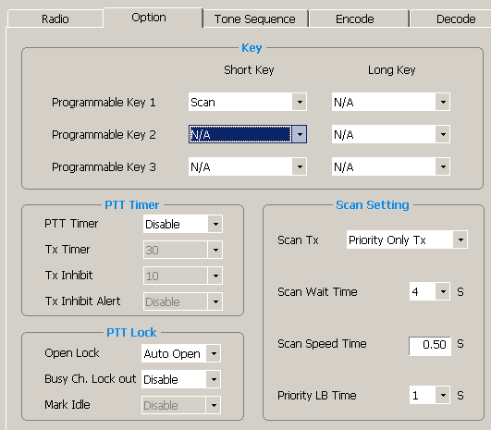
Open the option tab and select the required programmable key [P1] [P2] [P3], select scan using scroll bar.
With Priority Only TX selected, Scan wait time 4 sec. Scan speed 0.50sec. Priority LB Time 1 sec.
On pressing scan button, radio will traverse scan list, after each channel is scanned the radio will operate as follows: P1=Priority 1, S1=Scan channel P1→S1→P1→S2→P1→S3→P1→S4→P1.

Transmit is allowed on priority channel only, in any state. Scan edit can only be used on a stopped channel. Using the ▼ once scanned channel has locked will temporarily delete that channel from the scan list.
Scanning Parameters
With Priority Scan TX selected, Scan wait time 4 sec. Scan speed 0.50sec. Priority LB Time 1 sec.
On pressing scan button, radio will traverse scan list, after each channel is scanned the radio will operate as follows: P1=Priority 1, S1=Scan channel P1→S1→P1→S2→P1→S3→P1→S4→P1. Transmit is allowed on a stopped channel for a set time period the channel will then change to the priority where transmit is again permitted.

Priority Look Back Scan
One channel can be programmed by the dealer to be the Priority channel, which will enable ‘Look-back’. This mode of operation can be used outside of the normal scanning mode. Pressing the Scan button shall activate Priority Look-back. The Priority Look-back causes the radio to periodically ‘Look-back’ to the priority channel for the presence of a carrier regardless of the channel that the user may be on. The frequency that the radio will ‘Look-back’ to the priority channel can be programmed between 1 to 7 seconds in 1-second increments. When carrier, or carrier and tone, are removed, the radio will revert back to the previously selected channel.

Scan Channel Delete
Scanning Parameters
Pressing the “▼” (when in scan mode and stopped on the channel) shall temporarily delete the channel from the scan list. This shall remove that channel from the scan list until the channel is changed or the radio’s power is reset. When power is restored or the scan list channel position is selected again, the originally programmed scan list shall be activated.

Group Scan Edit Mode
You can edit your pre-programmed Group Scan List by adding or deleting scan list from the Group Scan List. To activate scan list editing, press and hold the P1 button on the front of the radio and turn volume on the radio. Upon entering the scan list edit function, the LCD displays the “Scan Edit” message. To exit the scan list edit function, turn volume off the radio.
1. Select the Scan Group
Each Scan Group would be displayed as “xx_nnn_ xx” which means group, and nnn means channel. To activate scan list editing for selected group, press the P1 button. You can change the Scan Group Number by pressing the ▲▼ buttons.
2. Adding or Deleting to Scan List
If each channel is in the ‘Scan Editable List’, Channel Number would display Scan Icon, to add or delete each channel to Scan Editable List, use P2 button.

Priority Scan Channel Edit
Priority Channel can be setup by PC programmer. Priority Scan List is also editable by the radio. It is called ‘Priority Channel Edit Mode’. If turn on the radio with pressing P2 Button, the radio enters Priority Channel Edit Mode. In the Priority Edit Mode, the LCD displays the “PscanEdit” message.
1. Select the Priority Group
Each Scan Group dispalys “xx_nnn_xx” means the current Group and ‘nnn’ means channel. To activate P scan list editing for selected Priority group, press the P1 button. You can change the Priority Group Number by up or down button.
Scanning Parameters
2. Adding or Deleting to P Scan List
If each channel is included in P Scan Editable List, Channel Number would display “Pscan” Icon. To add or delete channel from P Scan Editable List, use P2 button.

Selcall Tones and Sequences
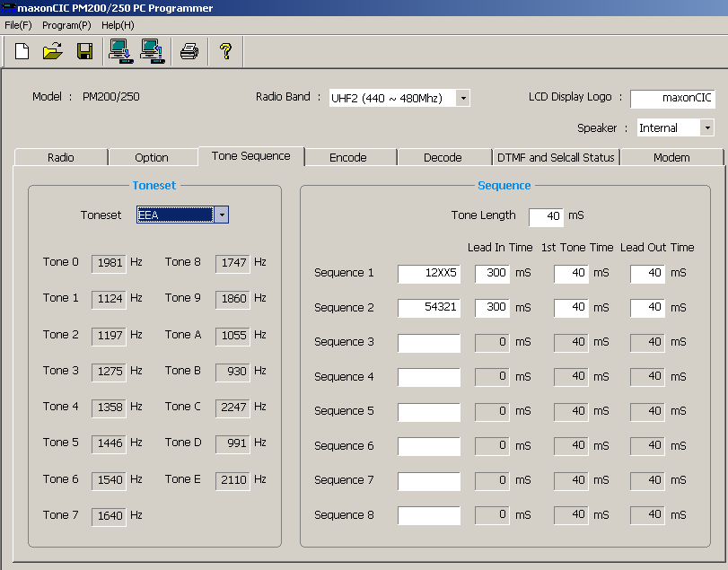
Selcall Tones and Sequences
(Fig.18)

Tone Sets
There are a number of internationally used Tone Sets. A Tone Set defines the audio frequencies representing each decimal (0 to 9) digit. Other tone frequencies that are not assigned to a decimal digit are also defined and these have special functions. The available Tone Sets are listed below:
Tonesets Tone No | EEA | ZVEI1 | ZVEI2 | ZVEI3/  DZVEI | CCIR | PZVEI | CCITT | USER
0 | 1981 | 2400 | 2400 | 2200 | 1981 | 2400 | 400 | U/D
1 | 1124 | 1060 | 1060 | 970 | 1124 | 1060 | 697 | U/D
2 | 1197 | 1160 | 1160 | 1060 | 1197 | 1160 | 770 | U/D
3 | 1275 | 1270 | 1270 | 1160 | 1275 | 1270 | 852 | U/D
4 | 1358 | 1400 | 1400 | 1270 | 1358 | 1400 | 941 | U/D
5 | 1446 | 1530 | 1530 | 1400 | 1446 | 1530 | 1209 | U/D
6 | 1540 | 1670 | 1670 | 1530 | 1540 | 1670 | 1335 | U/D
7 | 1640 | 1830 | 1830 | 1670 | 1640 | 1830 | 1477 | U/D
8 | 1747 | 2000 | 2000 | 1830 | 1747 | 2000 | 1633 | U/D  Selcall Tones and Sequences
9 | 1860 | 2200 | 2200 | 2000 | 1860 | 2200 | 1800 | U/D
A | 1055 | 2800 | 885 | 825 | 2400 | 970 | 0 | U/D
B | 930 | 810 | 810 | 740 | 930 | 810 | 0 | U/D
C | 2247 | 970 | 740 | 2600 | 2247 | 2800 | 0 | U/D
D | 991 | 885 | 680 | 885 | 991 | 885 | 0 | U/D
E | 2110 | 2600 | 970 | 2400 | 2110 | 2600 | 0 | U/D
Tone Period (ms) | 40 | 70 | 70 | 70 | 100 | 100 | 100 | U/D
(Fig.19)
**NOTE – U/D = User Definable. The User column is for the User to enter his own tone frequencies.

Sequence
This section enables the programming of the different 5 tone analogue selcall sequences to be encoded by the “PM200” (ANI, emergency, group, call 1 – call 3). The letter “K” represents a number entered via the keypad, “S” represents status digit(s), “X” represents digits from the most recent decode. Up to 8 sequences can be entered (Seq 1 to Seq 8). These are referred to later on in the programmer with regards “Encode”. When “K” is used, the number of variable digits needs to be entered under ID digits.

Tone Length (ms)
The duration of the second and successive tones of the selcall sequence set for each of the 8 sequences. Time 0 - 1275

Lead in (ms)
This is the time delay between activating the transmitter and the transmission of the selcall string.

1st Tone (ms)
This is the duration of the first tone of the selcall sequence. To allow maximum flexibility the tone length does not change when the tone set is changed.

Lead Out (ms)
This is the time delay between the end of the selcall transmission and the de-activation of the transmitter.

Encode
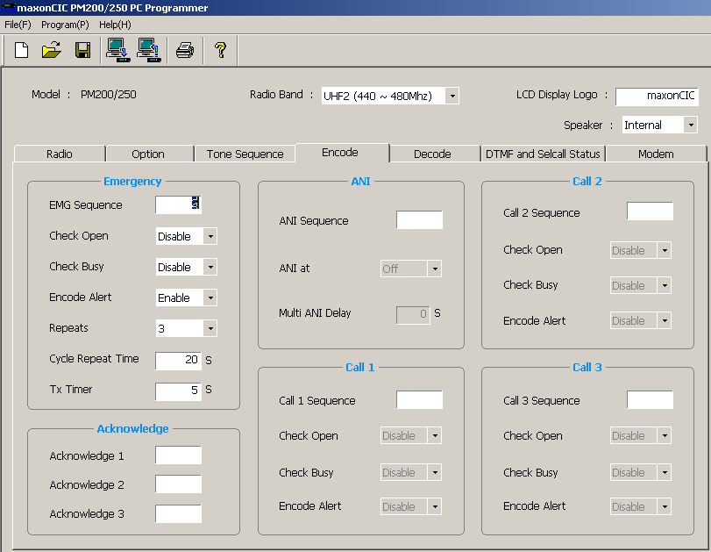
(Fig.20)

Emergency Sequence
This is where the sequence or set of sequences to be transmitted as the Emergency Call can be entered. This refers back to the “Tones and Sequences”, “Encode Sequences” section. Up to 3 sequences from 1-8 may be transmitted in series e.g. 26 might be entered here. This will transmit sequence 2 and sequence 6, as a 2 / 5 Tone Emergency sequence.
Selcall Encode

Check Open
Two options Enable/Disable. If set to Enable, Emergency Call can only be sent on an open channel, if set to No, an Emergency Call can be sent at anytime.

Check Busy
Two options Enable/Disable. If set to Enable, Emergency Call can only be sent on an unoccupied channel, if set to No, an Emergency Call can be sent at anytime.

Encode Alert
Two options Enable/Disable. If set to Enable the radio emits an audible alert to warn the user that an emergency has been transmitted. If set to Disable, no alert is given.

Repeats
This sets the number of times that the radio will repeat the emergency call. Ranging from OFF to Permanent.

Cycle Repeat Time
This is the time delay between re-transmissions of the Emergency sequence.

Transmit Timer
This is the time that the radio’s microphone is active during the emergency sequence. This time is part of the total repeat timer and must not exceed the cycle repeat time.

ANI
The ANI sequence is transmitted with respect to the depression of the PTT button. ANI can be sent either at the Start of TX or End of TX.

ANI Sequence
This is where the sequence or set of sequences to be transmitted as the ANI can be entered. This refers back to the “Tones and Sequences”, “Encode Sequences” section. Up to 3 sequences from 1-8 may be transmitted in series e.g. 26 might be entered here. This will transmit sequence 2 and sequence 6, as a 2 / 5 Tone ANI sequence. If no ANI is required then this must be left blank.

ANI at
This is where it is defined when the ANI sequence is transmitted. 3 options are available to choose from - OFF, START, and END.
Selcall Encode

Multi ANI Delay
This is the time delay between re-transmissions of the ANI sequence.

Call 1 / Call 2 / Call 3 Sequence
This is where the sequence or set of sequences to be transmitted as Call 1 / Call 2 can be entered. This refers back to the “Tones and Sequences”, “Encode Sequences” section. Up to 3 sequences from 1-8 may be transmitted in series e.g. 26 might be entered here. This will transmit sequence 2 and sequence 6, as a 2 / 5 Tone Call sequence. Varying the length of the first tone of a second sequence will have the same effect as providing an intersequence gap.

Check Open
Two options Enable/Disable. If set to Enable, a Call (1 or 2) can only be sent on an open channel, if set to No, a Call (1,2 or 3) can be sent at anytime.

Check Busy
Two options Enable/Disable. If set to Enable, a Call (1 or 2) can only be sent on an unoccupied channel, if set to No, a Call (1 or 2) can be sent at anytime.

Encode Alert
Two options Enable/Disable. If set to Enable the radio emits an audible alert to warn the user that a Call has been transmitted. If set to Disable, no alert is given.

Ack. 1 to Ack. 4

Sequence
This is where the sequence or set of sequences to be transmitted as an Acknowledgement (Ack. 1-3) can be entered. This refers back to the “Tones and Sequences”, “Encode Sequences” section. Up to 3 sequences from 1-8 may be transmitted in series e.g. 26 might be entered here. This will transmit sequence 2 and sequence 6, as a 2 / 6 ACK sequence.
If ‘X’ is included in the ACK sequence, the radio can be set up to call back the first radio (especially useful in a ‘closed’ system). This can be achieved by including the users own identity in the transmitted address but the acknowledge sequence will only include the receive address of first radio.
Selcall Encode

Decoder
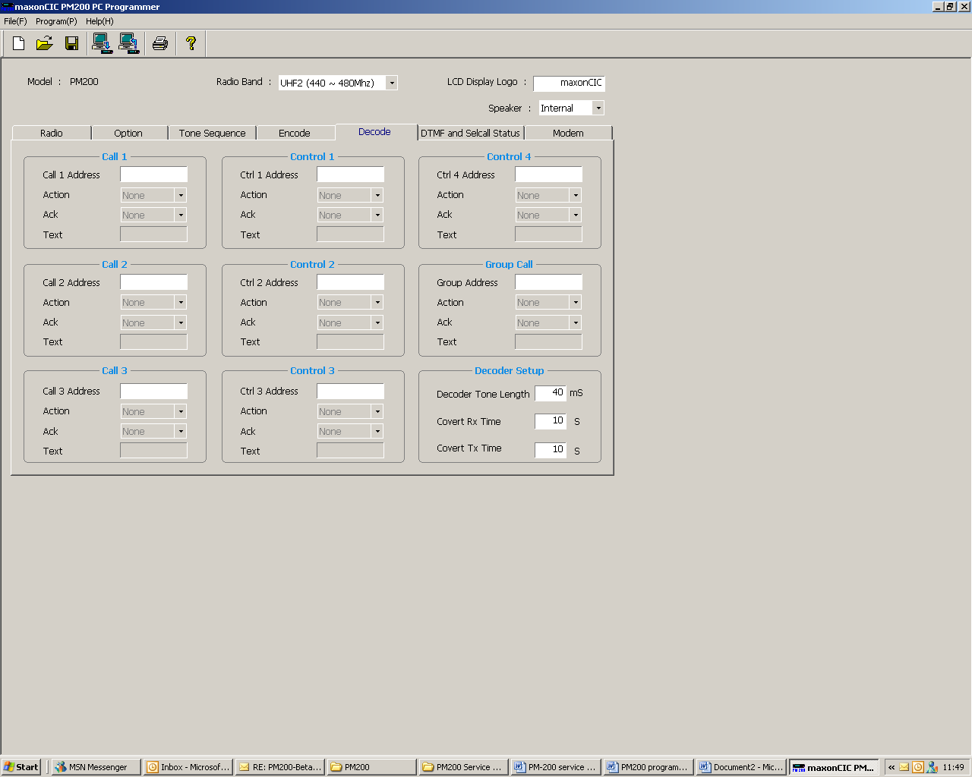

(Fig.20)

Call 1 / Call 2 / Call 3
Call 1 Address, Call 2 Address, and Call 3 Address
This selects the selcall string to be decoded. Up to 8 digits from 0-9, and A. B. C. D. E. The tone set will be that of the encode.
Selcall Decode

Control 1 to 4
Ctrl 1 Address, Ctrl 2 Address, Ctrl 3 Address and Ctrl 4 Address
This selects the selcall string to be decoded. Up to 8 digits from 0-9, and A. B. C. D. E. The tone set will be that of the encode.

Action
When the correct selcall is detected the action is enabled. There are seven states associated with the Action.
Action |  | Description
None |  | No action is performed with correct Five tone
Close |  | Radio is muted with correct Five tone
Open |  | Radio is un-muted with correct Five tone
Stun |  | Radio is stunned with correct Five tone
Revive |  | Radio is revived with correct Five tone
Covert on |  | Radio is put into covert mode with correct Five tone
Covert off |  | Radio is taken out of covert mode with correct Five tone

(Fig.21)

Close Remote muting of the speaker.
Open Remote un-muting of the speaker.
Stun Prevents any transmission from the radio and will also mute the speaker.
Revive Re-activates the radio.
Covert On Valid Secall causes the radio to cycle between TX mode and RX mode. The time periods spent in TX and RX modes are programmed into the addressee radio, however, it will be the Base Station or Selcall Sender that remotely turns this feature ON or OFF.
Selcall Decode
Covert Off Remotely turns the radio covert mode off, i.e. the radio will return back to passive receive mode.

Acknowledge
This selects the acknowledge string or strings to be transmitted after receiving Call 1 / Call 2 / Call 3. Please refer to the encode page Ack 1 – 3.

Selcall Text
When the correct sequence is received text is displayed. Up to 8 characters / numbers.

Group Call
Specifically used for group calling i.e. the same decoder address sequences across a group.
(Please see action of call addresses, as the same actions apply to the group call).

Decoder Tone Length
This is the expected length of incoming tones to decode. This length must be the same as the longest tone length as defined in section.

Covert Timer
The covert feature enables the remote activation of the transmitter/receiver by another operator via the reception of a valid selcall. This mode is switched on and off by selcall.

TX Timer
This is the length of time that the radio’s microphone is active.

RX Timer
This is the length of time that the radio’s receiver is active.

Selcall Decode

DTMF and Selcall Status

Selcall Status
There are 9 Selcall decode Status addresses, 8 characters can be used Alpha/Numeric. Please note on the encoding radio the last two digits of the relevant tone set sequence should be set to SS. e.g. 123SS. The last two digits are variable and relate to the status numbers e.g. 01 – 10.
Selcall Status is located on the DTMF and Selcall Status tab.

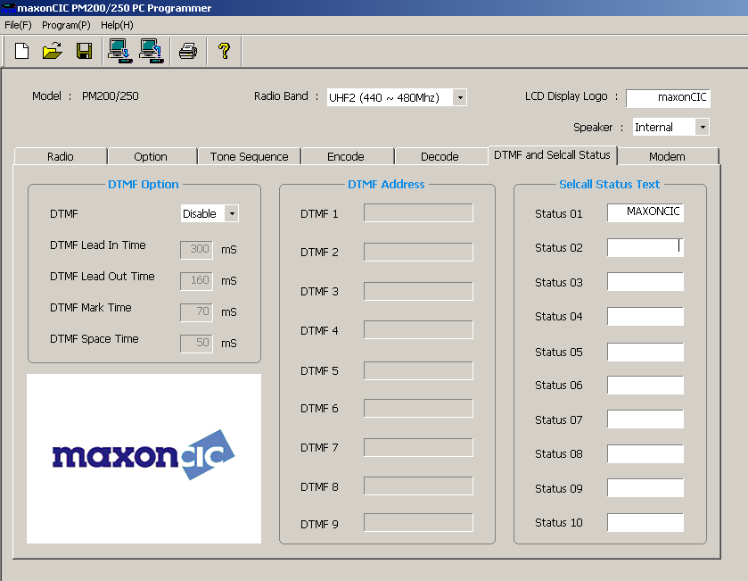 (Fig.22)
DTMF and Selcall Status

DTMF Tone Frequencies
 | 1209hz | 1336hz | 1477hz | 1633hz
697hz | 1 | 2 | 3 | A
770hz | 4 | 5 | 6 | B
852hz | 7 | 8 | 9 | C
941hz | * | 0 | # | D

(Fig.23)

DTMF
Short for Dual Tone Multi-Frequency, the system used by touch-tone telephones. DTMF assigns a specific frequency (consisting of two separate tones) to each number so that it can be easily identified by a microprocessor.
Select enable / disable making sure that one of the programmable keys has been assigned to DTMF on the options page.

DTMF Lead in Time
This is the time that the radio’s transmitter is active before the first DTMF digit is transmitted (recommended 300ms).

DTMF Lead out Time
DTMF Lead out time is the amount of time the transmitter is on after the DTMF is sent 0 – 1000 ms

DTMF Mark Time
Mark Time
The mark time is the amount of time = Positive slope
DTMF and Selcall Status
0 – 100ms
DTMF Space Time
Space Time
The Space time is the amount of time = Negative slope
0 – 100ms

DTMF Address
This is where the sequence or set of sequences to be transmitted as DTMF 1 ~ 9 can be entered. Up to 15 Characters from 0-9, a -d, *, # may be transmitted.

Modem SMS
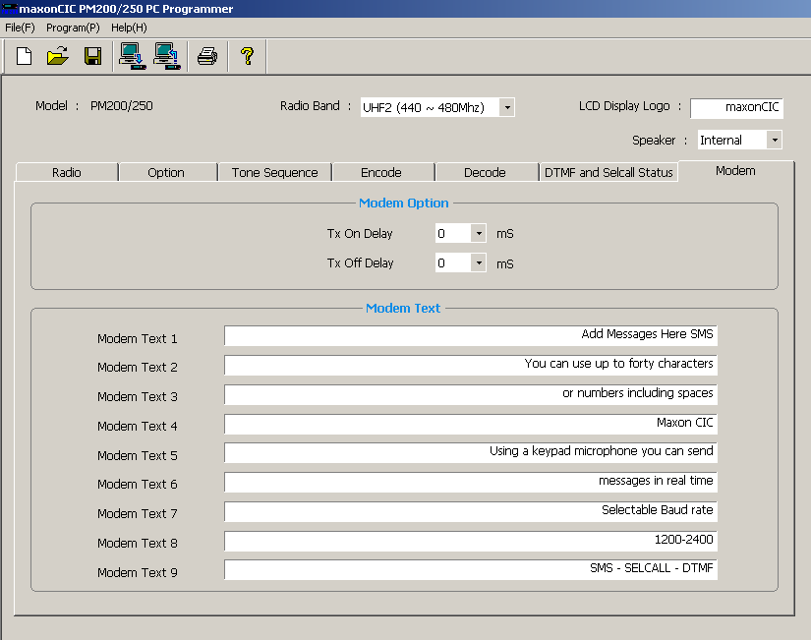

(Fig.24)

SMS
The SMS (short message service) is a pre-programmed short message that can be sent over air. Check that one of the programmable keys has been assigned to SMS on the options page. Please note using a Keypad microphone real time messaging can be achieved.
Select the correct baud rate by programming one of the programmable keys.
Modem SMS

TX On Delay
Time delay between when the transmitter is enabled and modulated data signal is sent.

TX Off Delay
Gap between when modulated signal has finished and transmitter switches off.

Contact Details
Contact Details
Should you have any queries regarding this manual, or the information within it, please contact:

Maxon House,
Cleveland Road,
Hemel Hempstead,
Hertfordshire,
United Kingdom,
HP2 7EY

Tel: + 44 (0) 1442 267 777
Fax: + 44 (0) 1442 215 515
info@maxoncic.co.uk
www.maxoncic.co.uk

Technical Support:
Tel: + 44 (0) 1442 226 170
Email: technicalsupport@maxoncic.co.uk

Customer and Sales Support:
Telephone : + 44 (0) 1442 267 777
Email: sales@maxoncic.co.uk

Repairs:
Tel: + 44 (0) 1442 267 777
Email: repairs@maxoncic.co.uk

